Lab Report 6

EEE 3400 :Numerical Techniques Laboratory

Student Name: Md. Hussain Shahriar Rokon
ID: 0212330092

Answer for Practice Problem 5
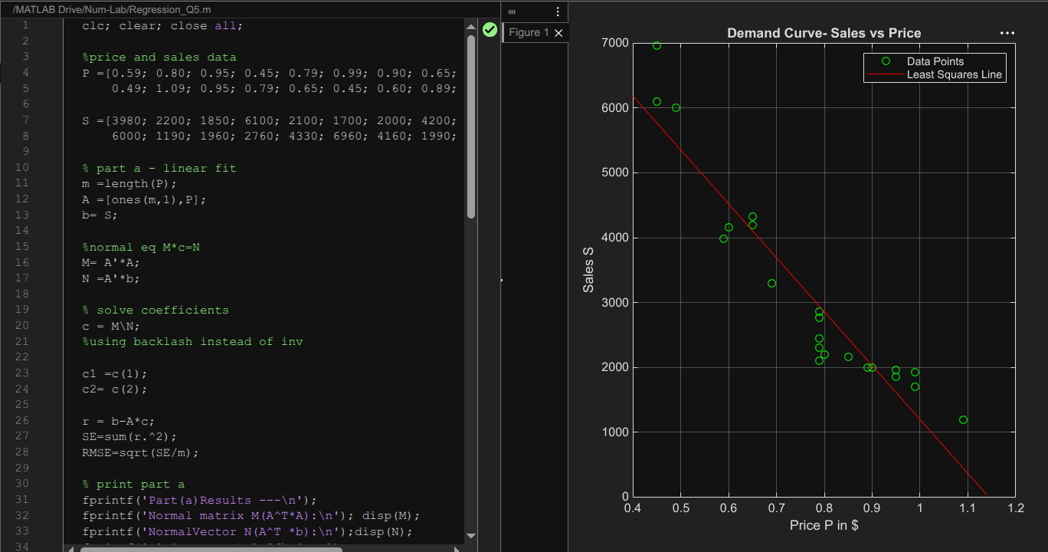

Matlab Code:
clc; clear; close all;
%price and sales data
P =[0.59; 0.80; 0.95; 0.45; 0.79; 0.99; 0.90; 0.65; 0.79; 0.69; 0.79; ...
0.49; 1.09; 0.95; 0.79; 0.65; 0.45; 0.60; 0.89; 0.79; 0.99; 0.85];
S =[3980; 2200; 1850; 6100; 2100; 1700; 2000; 4200; 2440; 3300; 2300; ...
6000; 1190; 1960; 2760; 4330; 6960; 4160; 1990; 2860; 1920; 2160];
% part a - linear fit
m =length(P);
A =[ones(m,1),P];
b= S;
%normal eq M*c=N
M= A'*A;
N =A'*b;
% solve coefficients
c = M\N;
%using backlash instead of inv
c1 =c(1);
c2= c(2);
r = b-A*c;
SE=sum(r.^2);
RMSE=sqrt(SE/m);
% print part a
fprintf('Part(a)Results ---\n');
fprintf('Normal matrix M(A^T*A):\n'); disp(M);
fprintf('NormalVector N(A^T *b):\n');disp(N);
fprintf('c1 Intercept)=%.2f\n', c1);
fprintf('c2(Slope)= %.2f\n', c2);
fprintf('RMSE= %.2f\n\n', RMSE);
% plot demand line
P_arr=min(P)-0.05:0.01:max(P)+0.05;
S_fit=c1 + c2*P_arr;
figure;
plot(P,S,'o','MarkerEdgeColor','g'); hold on;
plot(P_arr,S_fit,'r-');
grid on;
title('Demand Curve- Sales vs Price');
xlabel('Price P in $');
ylabel('Sales S');
legend('Data Points','Least Squares Line');
% part b- max profit
P_opt =(0.23*c2- c1)/(2*c2);
Max_Profit=(c1+c2*P_opt)*(P_opt -0.23);
fprintf('Part(b)Results ---\n');
fprintf('Optimal Selling Price= $%.2f\n', P_opt);
fprintf('Maximum Profit = $%.2f per city/week\n', Max_Profit);

